Agenda-To get the total quantity of items sold in a category

First create your own data type and then make a sub report

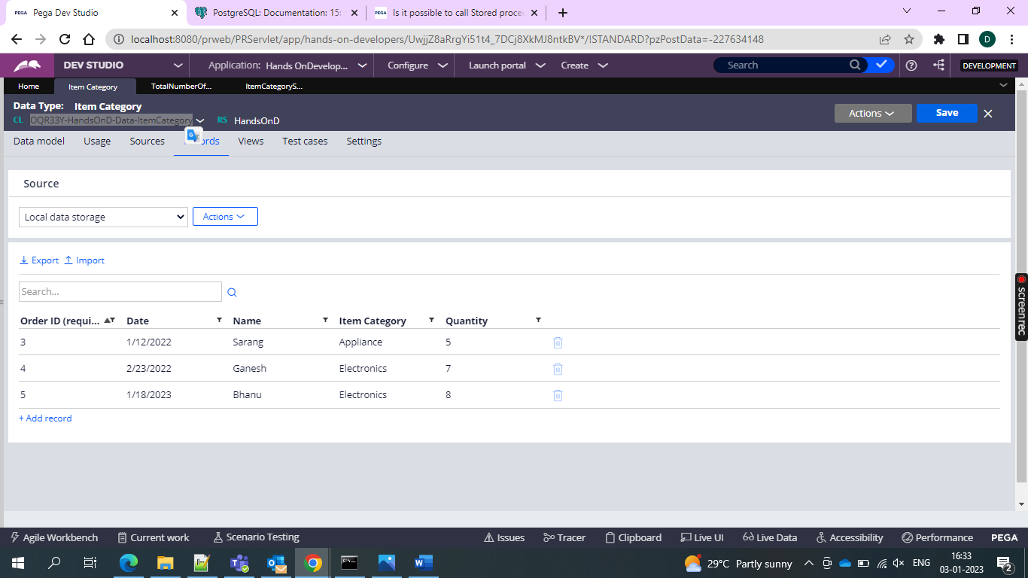

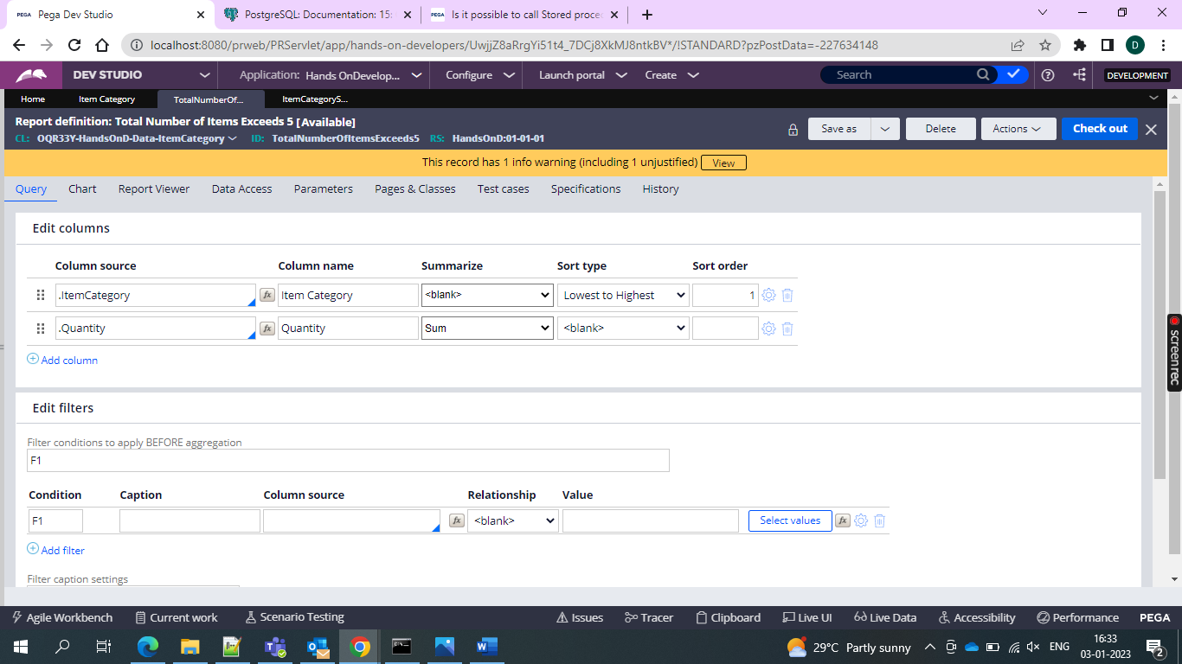

And then use this sub report in the main report

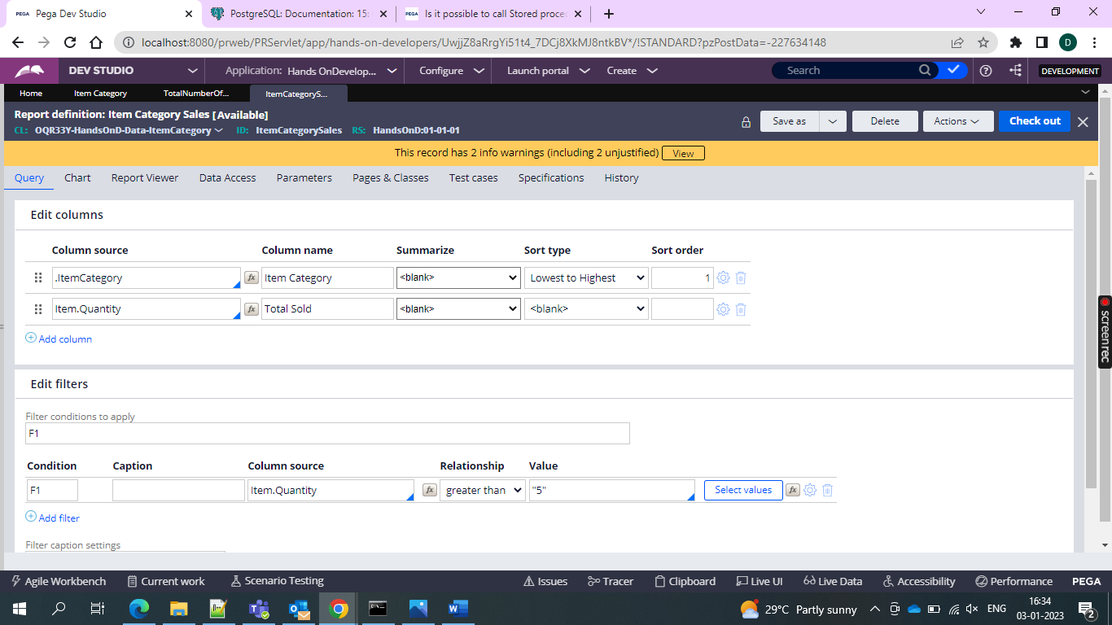

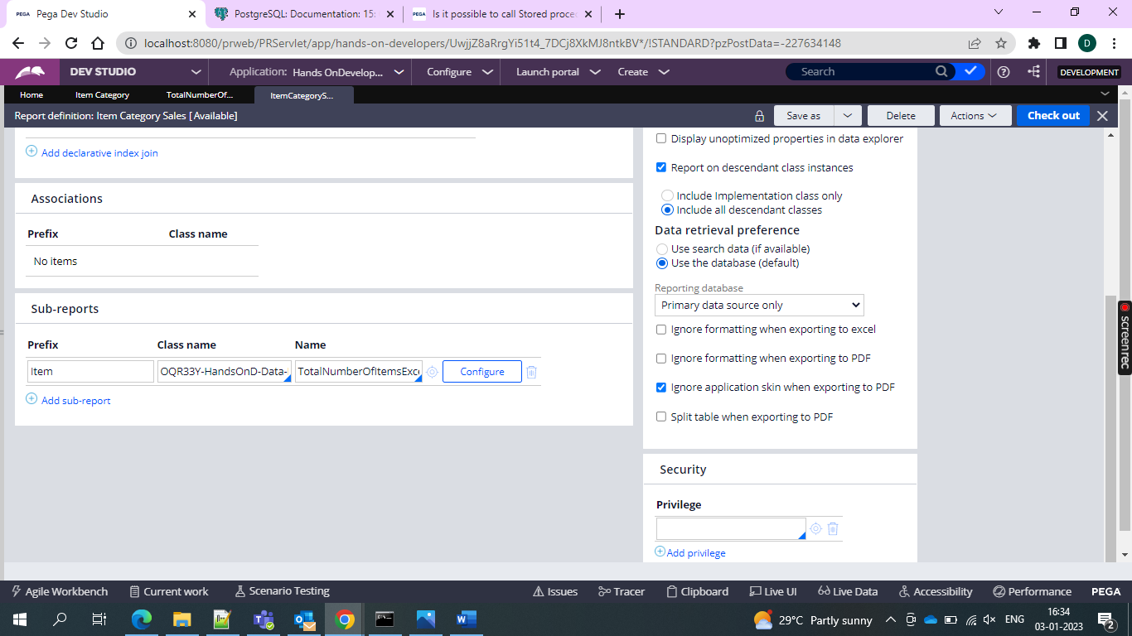

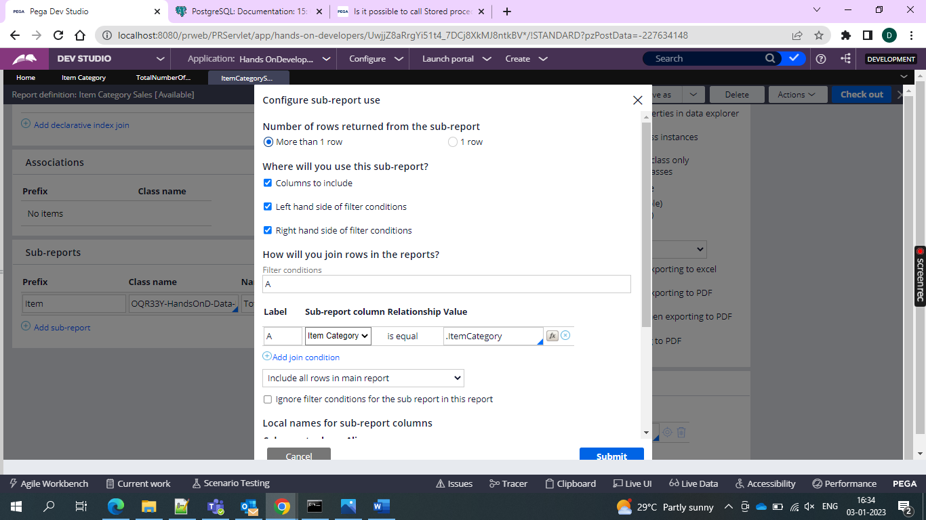

And then we must go for the run of the report

So total items that exceed the sales of 5 are displayed.